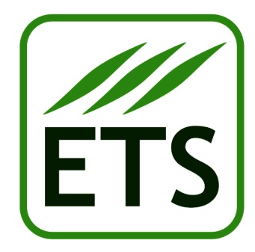 | The 6th ETS Field Days  Padova (IT)  27th-28th MAY 2019

SPONSORSHIP PACKAGE ACCEPTANCE FORM
TOP SPONSOR

(please fill in and email to etsoffice@turfgrasssociety.eu)

Company name: ________________________________________________________________________
Company address: ______________________________________________________________________
Town: _______________________ Postcode: __________________ Country: _____________________
Telephone: _________________________________, Fax: ______________________________________
Email: _____________________________________, Website: __________________________________
Company’s core business(es): _____________________________________________________________
_______________________________________________________________________________________
Company reference person: ______________________________________________________________
Company delegate(s) that will be attending the 6th ETS Field Days (2 delegates for the TOP sponsors):
- Full name:_________________________________ Email:________________________________
- Full name:_________________________________ Email:________________________________

We have read the Sponsorship Package Proposal of the 6th ETS Field Days 2019 and we agree with all the terms described in the “Sponsoring proposal for the 6th European Turfgrass Society Field Days 2019”. Therefore, please send us the following:

- Invoice for € 2.000 (TOP SPONSOR)
- Bank account details for sponsorship funds transfer.

Best regards,

Date: __________________

Company’s representative signature:_____________________________

